MUHAMMAD TARMIDZI BARIQ

51422161

2IA11

1.

SELECT

COUNT(DISTINCT customerNumber) AS Customers,

COUNT(DISTINCT city) AS Cities,

COUNT(DISTINCT country) AS Countries

FROM

customers;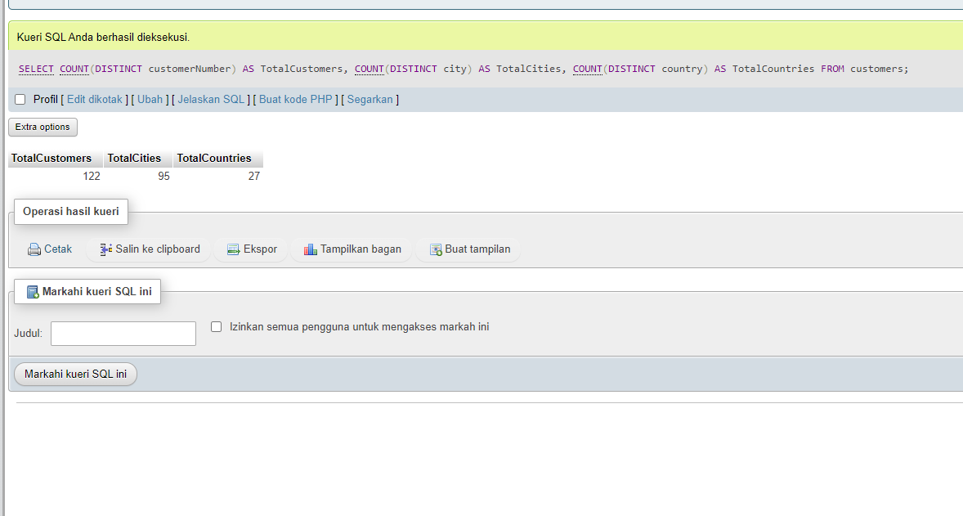



2.

SELECT

(SELECT COUNT(\*) FROM employees) AS Employees,

(SELECT COUNT(\*) FROM offices) AS Offices,

(SELECT COUNT(DISTINCT country) FROM offices) AS Country,

(SELECT COUNT(\*) FROM products) AS Products,

(SELECT SUM(quantityInStock) FROM products) AS StockProducts,

(SELECT COUNT(DISTINCT productVendor) FROM products) AS Vendors

;

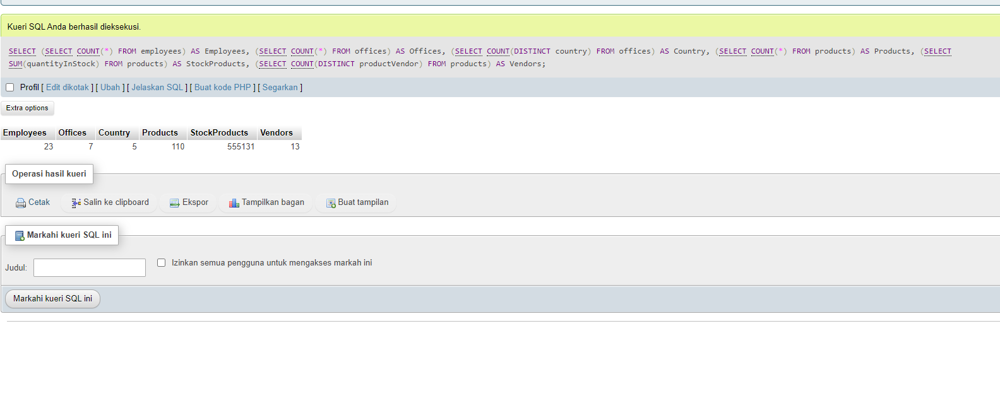

3.

SELECT

productLine,

MIN(buyPrice) AS LowestPrice,

MAX(buyPrice) AS HighestPrice

FROM

products

GROUP BY

productLine;

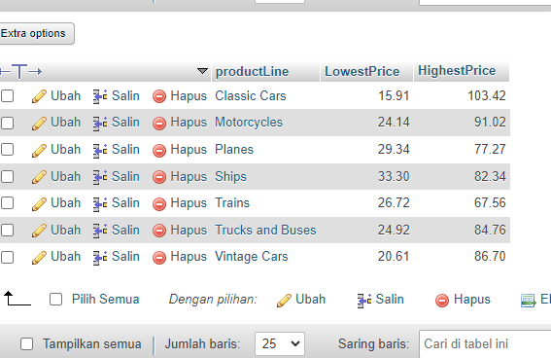

4.

SELECT

c.customerName,

c.city,

c.country,

SUM(p.amount) AS totalSpent

FROM

customers c

JOIN

payments p ON c.customerNumber = p.customerNumber

GROUP BY

c.customerNumber

ORDER BY

totalSpent DESC

LIMIT 10;

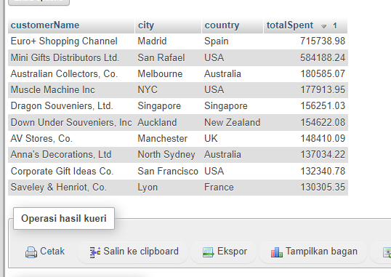

5.

SELECT c.customerName, p.productName, od.quantityOrdered, od.priceEach

FROM customers c

JOIN orders o ON c.customerNumber = o.customerNumber

JOIN orderdetails od ON o.orderNumber = od.orderNumber

JOIN products p ON od.productCode = p.productCode

JOIN payments pay ON o.customerNumber = pay.customerNumber

WHERE pay.paymentDate = '2003-06-05' AND pay.amount = 14571.4

LIMIT 4;

